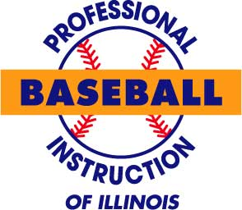

HIGH SCHOOL FALL/WINTER INDOOR BASEBALL @ LBFH

Professional Baseball Instruction is offering an 8 week indoor baseball league at the Lake Barrington Field House beginning in November 2008. The program begins Sat November 1st and will go every Saturday through Dec 27th. (except Nov29th) This program is offered to HS aged players only and will consist of professional training from the PBI-IL staff on all aspects of the game. This is a great way for HS players to stay in tune. There will be limited space available so sign up soon. Play will take place on the LBFH 90,000 sq ft indoor field, 35 ft high and netted to separate into two full fields.

Goals of the program:
- Prepare players to begin their High School practice season at peak performance, both physically and mentally.
- Condition players to top personal performance
- Improve players’ position specific skills and knowledge.

Live Competition:
Throughout the program the main focus of the workouts will be live competition and game situations. Each hitter will get plenty of at bats, while each pitcher will get much needed innings pitched.
- Pitchers will throw live to hitters.
- Hitters will take live at bats.
- Catchers catch during live situations & throw full distance to all bases.
- Infielders will take live ground balls & make full distance throws.
- Position players will base-run in live game situations.
- All players will work on live defensive situation, such as 1st & 3rd defense, bunt defenses, run-downs, and pick-off plays.

Where:Lake Barrington Field House
When: Nov: Saturdays-1st, 8th, 15th, 22nd
Dec: Saturdays-6th, 13, 20th, 27th
Time: Nov: 8:15-10am
Dec: 9:15- 11am
What to Bring: Baseball attire, glove, bat, helmet(optional) spikes, and turf shoes. Pitchers will NOT where spikes.
Cost: $375.00

